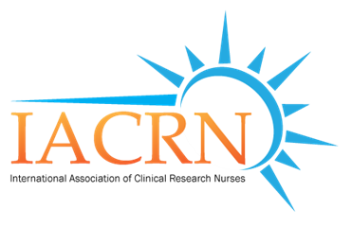

Committee Interest Form

Upon completion you will be contacted to discuss your form. Thank you for your interest.

Full Name _____________________________________________________________________________________________

Credentials _____________________________________________________________________________________________

Employer _____________________________________________________________________________________________

Current Title _____________________________________________________________________________________________

Address ______________________________________________________________________________________________

Country ______________________________________________________________________________________________

Preferred Contact Email ____________________________________________________________________________________

Preferred Phone Number ___________________________________________________________________________________

Committee(s) Interests ___________________________________________________________________________________
(For a description of each committee, please go to our website at www.iacrn.org).

Please check all that apply.
_____ Chapter Governance Committee
_____ Conference Planning Committee
_____ Research Committee
_____ Education
_____ Membership, Marketing and Communications Committee
_____ Nominations Committee

Previous experience which demonstrates your ability to contribute to the vision and mission of IACRN

Strengths which you bring to your IACRN committee of choice

Will you be submitting a current CV of yourself?
If so, please email them to Debbie Zaparoni at debbie@iacrn.org.
(Cell phone pictures are acceptable.)

Thank you again for your interest! Please send the completed form and any attachments to Debbie Zaparoni at debbie@iacrn.org.

